Town and Village of Walton

Program for Public Information

2017

Village of Walton Town of Walton

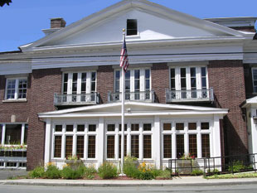 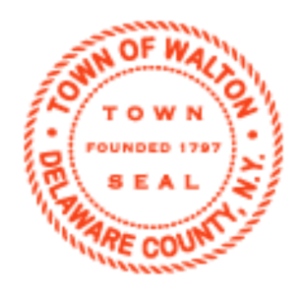

129 North St.

Walton, NY 13856

MUNICIPAL BUILDING

21 NORTH STREET PO BOX 29

WALTON, NY 13856

607-865-4358

[vclerk@stny.rr.com](mailto:vclerk@stny.rr.com)

[www.villageofwalton.com](http://www.villageofwalton.com)

TDD 1-800-662-1220

Table of Contents

Background 3

Walton Flood Commission 4

Flood Commission Members: 4

Technical Assistance: 4

Target Areas 5

Target Audience – Public Information Needs 8

National Flood Insurance Program (NFIP) 12

Activity 320 Map Information Service (Topics, publicity prerequisite) 13

Activity 330 Outreach 14

Activity 340 Hazard Disclosure 18

Activity 350 Flood Protection Information 18

Activity 360 Flood Protection Assistance 19

Activity 370 Flood Insurance Promotion 20

Flood Insurance Coverage Assessment (FIA) 20

Activity 420 Open Space Preservation (NFOS5) 20

Activity 610 Flood Warning and Response 22

Annual Evaluation 23

Adoption 24

# Background

The Town and Village of Walton are located in the western central portion of Delaware County, upstream from the Cannonsville Reservoir, part of the Catskill/Delaware drinking water supply system for New York City. New York State Route 10 passes through the Town from east to southwest and New York State Route 206 passes through from northwest to southeast. The two state highways intersect in the Village of Walton, located at the very center of the Town. The Town of Walton has a total area of 97.6 square miles.

The West Branch of the Delaware River is the main channel that flows through the Town and Village of Walton. Tributaries with confluence to the West Branch Delaware River include: Oxbow Hollow, Marvin Hollow, East Brook, West Brook, Third Brook, Pines Brook, Bobs Brook, Wakeman Brook, Chase Brook, Weeds Brook and Beers Brook. East Brook, West Brook and Third Brook flow through the Village of Walton with their confluence to the West Branch Delaware River being in the center of the village.

The town and village experienced a 100 year flood event in 1996 and again in 2006. There were several other high water events recorded within this time frame as well.

In response to these flooding events a committee was formed in 2010 in an effort to address the flooding issues faced by both communities. This committee became known as the Walton Flood Commission. The commission has remained committed to their duty and functioning since its inception.

In 2015, both communities enrolled in the Community Rating System (CRS) program. Through this process it became evident that the Walton Flood Commission had been effectively functioning as the multi-jurisdictional committee as described by the CRS Program for Public Information (PPI) for the town and village. Over the past five years, the commission has identified flood hazards, identified flood hazard mitigation projects, identified target audiences and instituted outreach projects to reach those audiences. It was decided on September 3, 2015 by the commission to formalize their outreach efforts through the CRS PPI. A draft of the PPI was created on September 14, 2015 and was submitted to the Walton Flood Commission for review and comments on January 7, 2016. The PPI document was submitted to the Community Rating Program for review. The Walton Flood Commission will follow the PPI guidelines to provide a better focus to their public outreach.

# Walton Flood Commission

The Walton Flood Commission was formed in 2010 for the purpose of identifying flood risks in the community, educating the public on flood risks and identifying and prioritizing projects that reduce the impacts on flooding. The current members and technical advisors of the commission are:

## Flood Commission Members:

Ed Snow Walton Village Mayor and floodplain resident

Charlie Gregory Walton Town Supervisor and floodplain resident

Roger Clough Walton School District Superintendent and floodplain resident

Gale Sheradin Town of Walton Planning Chair

Andy Jackson Village of Walton Planning Chair and floodplain resident

Stephen L. Dutcher, CFM Town and Village of Walton Code Enforcement/Floodplain Manager

Walt Geidel Town of Walton Highway Superintendent

Roger Hoyt Village of Walton Highway Superintendent

Bill Brown Village Engineer, Delaware Engineering DPC

Bruce Dolph Business owner and floodplain resident

Carl Fancher Walton Fire Department and floodplain resident

Len Govern Walton Fire Department and floodplain resident

Abby Butler Walton Reporter

John Mathiesa Catskill Watershed Corporation

Ed Rossley Delaware Valley Agricultural Society, President

John Veleber Wayne Bank

## Technical Assistance:

Graydon Dutcher, CFM Stream Program Coordinator, Delaware County SWCD

Jessica Patterson, CFM Stream Program Technician, Delaware County SWCD

Rick Weidenbach Executive Director, Delaware County SWCD

Nate Hendricks, CFM NYC DEP

Phil Eskeli, CFM NYC DEP

Dean Frazier Commissioner, Delaware County Department of Watershed Affairs, County Public Information Officer

Molly Oliver Delaware County Department of Watershed Affairs

Glen Nealis Director, Delaware County Department of Economic Development

Shelly Johnson-Bennett Delaware County Planning Department

Everett Farrell Delaware County Planning Department

Meetings are scheduled for the first Thursday of every month. Agendas are managed by SWCD staff with topics placed on the agenda as requested by members. The first meeting of the commission was held on May 20, 2010.

In 2013, a process for identifying local flood hazards and mitigating those hazards was developed by a committee which included representatives from New York City Department of Environmental Protection, New York State Department of Environmental Conservation, Delaware County Soil and Water Conservation District and numerous other stakeholders. The process was finalized and adopted by all stakeholders and is known as a Local Flood Analysis (LFA). The LFA identifies flood hazards on a given reach of stream through modeling then identifies potential mitigation projects. Public meetings are held throughout the process to both inform and get information from the people that occupy the study area. The commission formally adopted the LFA as the primary program by which flood mitigation projects are identified and chosen. The commission’s task is to guide this process by identifying the impacted areas to study and to recommend mitigation projects to the respective communities.

The Town and Village of Walton have adopted the Delaware County Multi-Jurisdictional Hazard Mitigation Plan that was finalized in March 2013, which should be credited under the CRS Activity 510. This PPI enhances the training, education and outreach that was outlined in the Mitigation Plan.

# Target Areas

Target areas are focus areas or priority areas within the Town and Village of Walton that have concerns related to floods or floodplains. These targets areas were identified using the Community Self Assessment tool found on-line at [www.CRSresources.org/200](http://www.CRSresources.org/200). The target areas include:

* Area 1: Downtown – Everything south of Mead Street and Benton Ave to the Village limits. Primarily business district, it has approximately 210 structures including some residential and critical facilities (Village Hall, School bus garage, grocery store). There are two major employers that are located in this area (Kraft and Big-M super market). When a flood event occurs, critical roads and bridges are impacted. Development is concentrated in the main business district with much less development in the areas immediately adjacent to the West Branch Delaware River on Water Street. Sufficient information about the hazards within this area are identified in the West Branch Local Flood Analysis plan.
* Area 2: East Brook Corridor – from Benton Ave north to the Town limit. It is a combination of residential neighborhood with a mix of business within the Village limits and less populated rural residential/farmland from the Village limit to the Town limit. It has approximately 91 structures and a critical facility (Townsend School). There are no major employers within this area. When a flood event occurs, critical roads and bridges are impacted. Much of this area has little undeveloped space within the Village limits and it is not expected to be redeveloped. From the Village limit to the Town limit there is much less development currently and future development is possible. There is currently sufficient information about the hazards within this area which are identified in the West Branch tributaries Local Flood Analysis plan.
* Area 3: West Brook Corridor – primarily a residential neighborhood with a mix of business within the Village limits and rural residential/farmland from the Village limit to the town limit. It has approximately 142 structures and no critical facility. There are no major employers within this area. When a flood event occurs, critical roads and bridges are impacted. Much of this area within the village limit has little undeveloped space and it is not expected to be redeveloped. There is currently sufficient information about the hazards within this area that are identified in the West Branch tributaries Local Flood Analysis plan.
* Area 4: Third Brook Corridor – mixed with business and residential within the Village limits and rural residential/farmland from the Village limit to the Town limit. It has approximately 12 structures and one critical facility (fire department). This area is subject to clogging of bridges due to debris which threaten the houses and businesses in the area even if not mapped in the SFHA. Much of this area within the Village limit is fully developed and it is not expected to be redeveloped. There is currently sufficient information about the hazards within this area that are identified in the West Branch tributaries Local Flood Analysis plan.
* Area 5: All other areas in the West Branch Delaware corridor east including the tributaries. This area is all in the Town of Walton and is primarily rural residential/farmland. It has approximately 55 structures. There are no major employers or critical facilities.
* Area 6: All other areas in the West Branch Delaware corridor south including the tributaries. This area is all in the Town of Walton and is primarily rural residential/farmland. It has approximately 55 structures. There are no major employers or critical facilities.

A review of building stock in the SFHA was conducted for the Town and Village of Walton. Table 1 summarizes the types and numbers of buildings in the SFHA for the respective communities.

**Table 1**

**Town and Village of Walton Building Stock in SFHA**

|  |  |  |  |  |
| --- | --- | --- | --- | --- |
|  | **Single Family** | **2-4 Family** | **Other Residential** | **Non Residential** |
| Village of Walton | 313 | 65 | 15 | 76 |
| Town of Walton | 34 | 0 | 9 | 8 |

Maps 1 & 2 below show FEMA floodway, 100-year and 500-year floodplains and the areas identified as target assessments areas that the PPI committee is going to be focusing on for public education and outreach efforts.

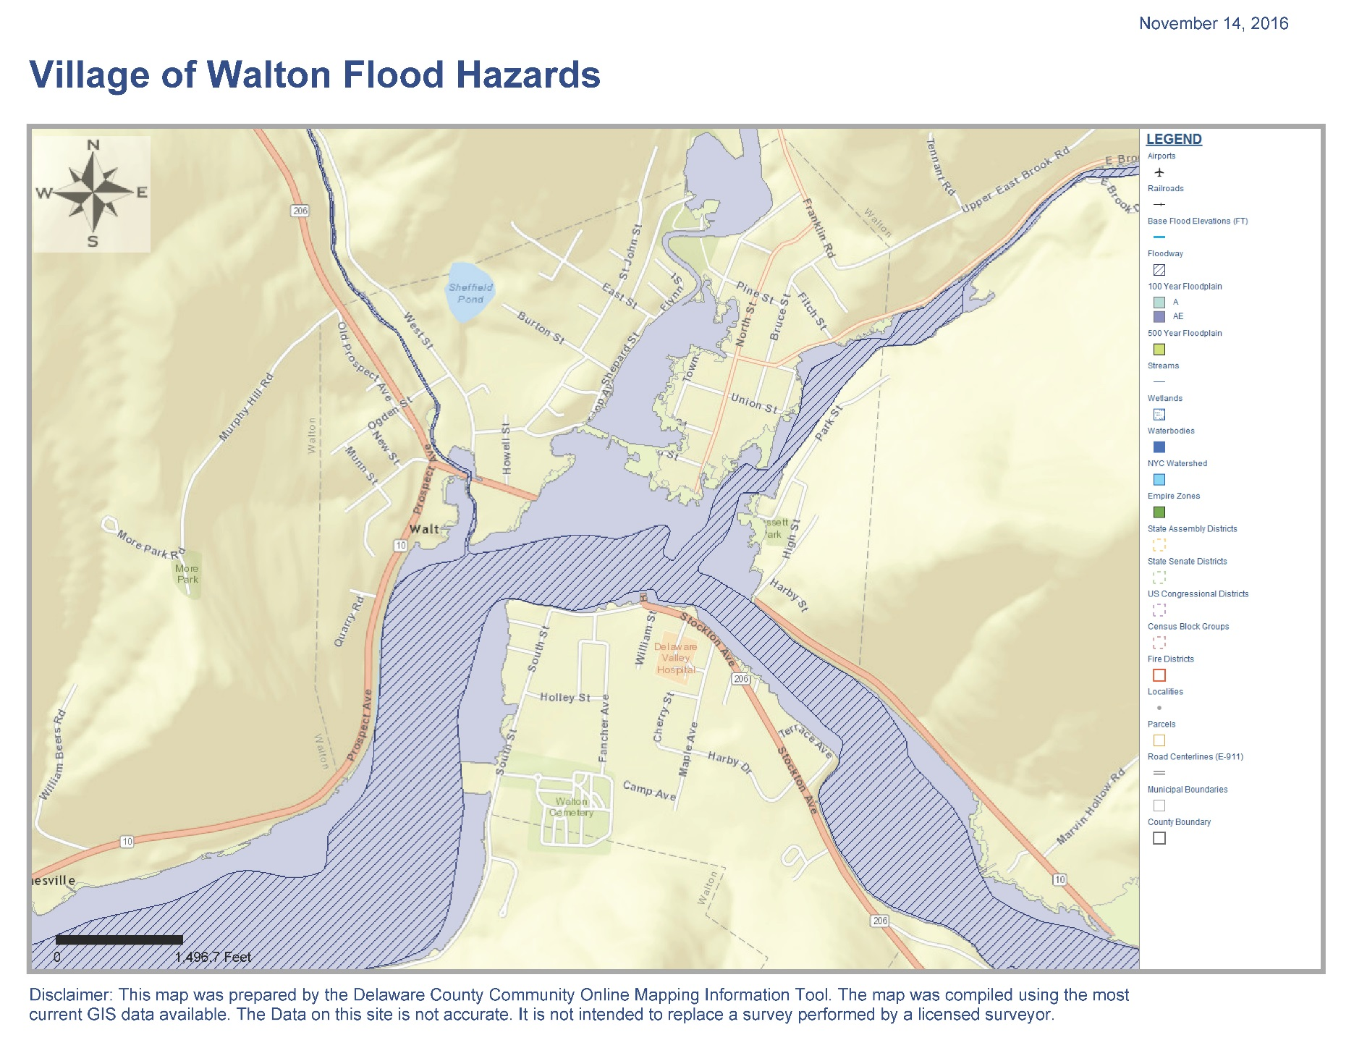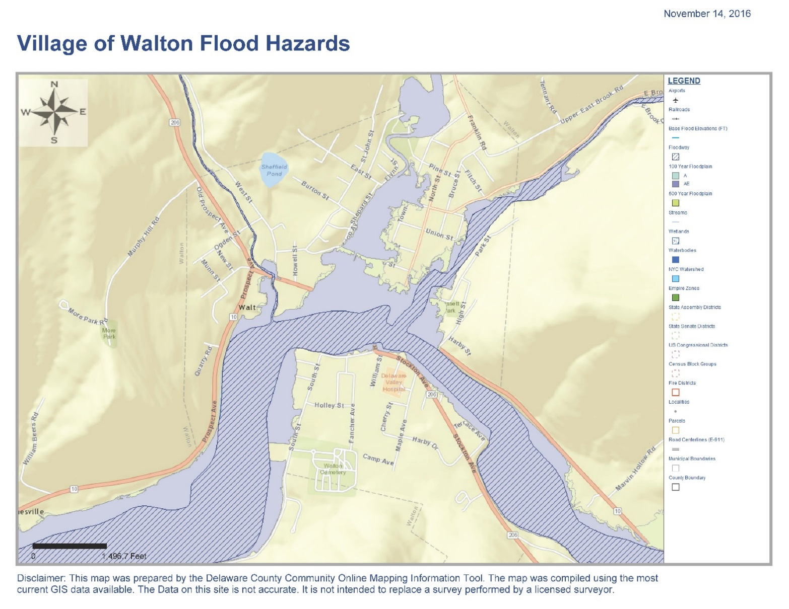

**Area 5**

**Area 6**

**Map 1**

**Area 4**

**Area 3**

**Area 2**

**Area 1**

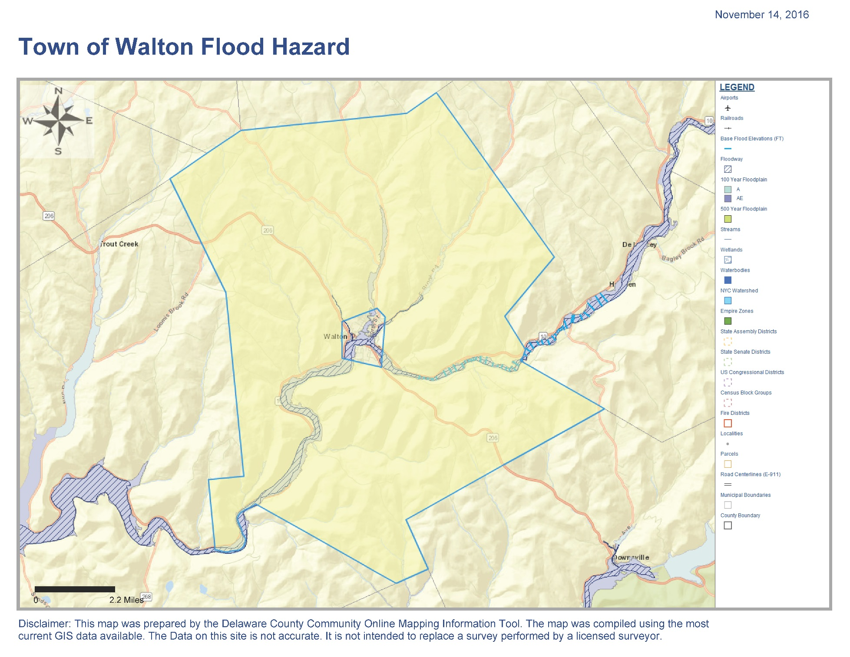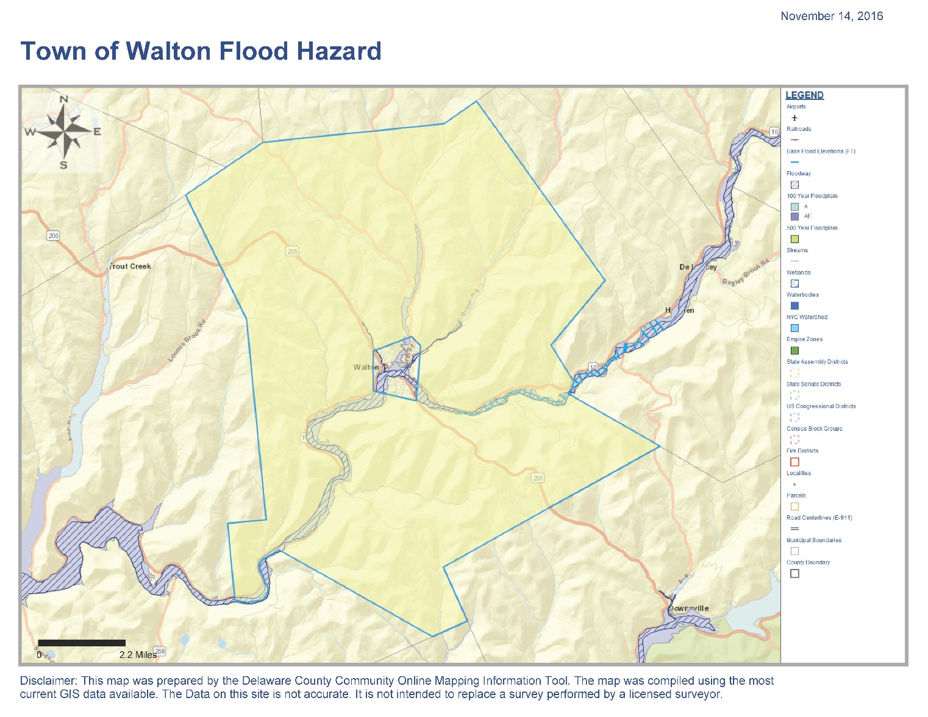

**Area 6**

**Area 5**

**Map 2**

**Area 1**

**Area 4**

**Area 3**

**Area 2**

# Target Audience – Public Information Needs

The flood commission is charged with identifying the impacted areas to study, conduct the public outreach and ultimately recommends mitigation projects to the municipalities. The municipalities make the final determination as to whether or not to proceed with the project. To date, the LFA has been completed for a reach of the West Branch of the Delaware River (WBDR) that flows through the village.

The commission started with the WBDR because it contributes to a Repetitive Loss Area (RLA). The goal was to establish a lowered flood elevation on the WBDR through mitigation projects which would benefit the properties located there and to have a target elevation for the LFAs on each of the three tributaries. The WBDR LFA was completed and accepted by both communities in the spring of 2015 and the LFA for the three main tributaries in the village got underway in the summer of 2015.

The commission’s public outreach focus has been directly related to the areas targeted for the LFA study which encompasses the Repetitive Lose Area (RLA) identified in the CRS process. Residents in the study area were mailed notifications of the public meetings and the meetings were also advertised in the local newspaper and radio stations. Attendance to these meetings has been low and the commission is working on strategies to get better public turnout for future meetings. The commission recognizes the importance of public participation in the development of the LFA.

The commission has also identified a need for a website as an outreach tool to get information out to the community. Currently the Town and Village maintain websites with a plethora of flood information however the commission feels a website dedicated to information directly related to the projects they are working on would be effective. The purpose of the website would be to provide a resource for the various mitigation plans for public access and to provide a way to keep the public up-to-date on the activities of the commission; upcoming public meeting dates, draft or final LFA plans etc. The website will inform the community what a flood commission is, what the commission has accomplished, what the commission is working on and how to contact members to find out additional information.

At the September 3, 2015 Flood Commission meeting the Community Rating System (CRS) Program for Public Information (PPI) was introduced. A motion was approved to formally designate the flood commission as the multi-jurisdictional committee for the PPI for the Town and Village of Walton. The goals of the PPI are to provide information to the public about the flood risks, what they can do to decrease future damage and the benefits of flood insurance so that the public can make informed decisions and get involved in flood reduction activities.

To fully assess the community’s public information needs, the commission started by documenting all known public information efforts being conducted by the communities and other agencies and organizations. Table 3 below summarizes existing outreach activities:

**Table 2**

**Existing Outreach Activities**

|  |  |  |  |
| --- | --- | --- | --- |
| **Organization** | **Projects** | **Subject Matter** | **Frequency** |
| **Town/Village Walton** | Flyers | Pre/Post Flood  Flood Insurance | Year Round |
| Website | Pre/Post Flood  Flood Insurance | Year Round |
| Repetitive Loss Area (RLA) Letter | Various flood related topics | Annually |
| Letter to Banks, Real Estate, Insurance Agents | Various flood related topics | Annually |
| Map Inquiry Service | Flood hazard areas, insurance, flood protection | Year Round |
| Signs | Historic Flood Depth | Year Round |
| Presentations | Know your flood hazards, Protect people from flood hazards, build responsibly, insure your property for your flood hazard | As needed |
| **Walton Flood Commission** | Outreach Presentations | Mitigation Projects, landowner stream walkovers | As needed |
| **Del. Co. Soil and Water** | Stream Table | Stream Mechanics | Annually at Fair and BOCES |
| Outreach Projects | Mitigation Projects | Annually at Fair and as needed |
| Student Outreach | Riparian Buffer projects | Annually events Walton High School and BOCES |
| Presentations | Floodplain functions, post-flood stream intervention training, stream mechanics, What are long-term solutions for reducing flood damages | As needed |
| **Citizens Preparedness Corps** | Training | Hazard Preparedness | Once 9/15/15 |

Outcomes of the education and outreach efforts:

1. Through the education and outreach presentation and handouts, encourage residents to adopt behaviors that improve flood hazard preparedness and decrease future flood damage. This can be accomplished by providing local information to residents regarding flood hazards largely focusing on residents that are located in special flood hazard areas. By providing detailed information to residents through direct mailings, publications, and even a property walk through to show the risk and possible remediation projects.
2. Sharing information and resources with community groups and organizations can help expand outreach efforts and achieve a larger audience.

The target audiences have been delineated by work previously completed by the flood commission. In short, the target audiences include:

* **Special Flood Hazard Areas (SFHA)** within the village limits are broken into separate stream reaches, or separate LFAs, including the West Branch of the Delaware River, and the tributaries East Brook, West Brook and Third Brook starting at their confluence with the WBDR and going upstream. The three tributaries reaches extend in to the town limits. As the LFA process moves forward in each target area the target audience are those affected by the LFA. The commission recognizes that additional outreach strategies may be needed to reach those properties in the SFHA but are not in a LFA.
* **Floodplain residents, renters and businesses.** All properties that are located within the SFHA. The committee has determined that all residents, renters and businesses should be aware of the flood hazards, ways to protect themselves and their property, and how to obtain flood insurance. The committee has identified ways to reach the general public and business through radio announcements, newspaper, direct mailing, door to door flyers, website, chamber of commerce, public events, and fair booth.
* **Building contractors.** It is important to educate contractors to the importance of acquiring appropriate permits whether construction is new or repair/improvements to existing structure. Provide training or educational material to contractors on flood related topics such as flood proofing , flood resilient materials, and elevation of utilities above the base flood elevation.
* **Surveyors.** Encouraging the public to obtain elevation certificates and providing surveyors with information and training on how to complete the elevation certificates.
* **Real estate brokers and agents, lending institutions and insurance companies.** Training agents that work with the potential homebuyers in flood insurance program, flood maps, and elevation certificates in order to provide information to their clients with best up-to-date information. The committee has identified ways provide training and offering continuing educational credits, brochures and other informational material.

# National Flood Insurance Program (NFIP)

National Flood Insurance Program policy information was provided to the local government agencies and was used to generate the summary tables below. The information provided below contains no specific policy holders name or address information and can be utilized in future outreach materials.

**Table 3**

**Village of Walton**

**Flood Insurance Inventory**

|  |  |  |  |
| --- | --- | --- | --- |
| **Occupancy** | **# Structures in SFHA** | **Policies In Force** | **% Covered** |
| Single Family | 159 | 75 | 47 |
| 2-4 Family | 65 | 13 | 20 |
| All Other Residential | 13 | 2 | 15 |
| Non Residential | 76 | 27 | 35 |
| Total | 313 | 97 | 30 |

**Table 4**

**Town of Walton**

**Flood Insurance Inventory**

|  |  |  |  |
| --- | --- | --- | --- |
| **Occupancy** | **# Structures in SFHA** | **Policies in Force** | **% Covered** |
| Single Family | 34 | 16 | 47 |
| 2-4 Family | 0 | 0 | 0 |
| All Other Residential | 9 | 1 | 11 |
| Non Residential | 8 | 3 | 37 |
| Total | 51 | 20 | 39 |

When taken together the reviews show that overall 30% of the building stock in the Village that is in the SFHA is insured and 39% of the building stock in the Town that is in the SFHA is insured. The committee determined an outreach campaign to increase participation in the NFIP in both communities would be beneficial. In particular the committee feels that targeting the owners and occupants of rental properties in the SFHA, especially in the Village, to be a priority. Rental housing is vital to the community and if owners and renters do not have the means to recover from a damaging flood it could be devastating to the local economy.

The PPI committee determined that the target audiences to focus on are SFHA residents, residents located in the Local Flood Analysis study area, first time home buyers, and realtors. Table 6 in Activity 330 Outreach summarizes the targeted audiences with the existing efforts, messages and outreach projects as identified by the commission. Education and outreach efforts will be evaluated by the Walton Flood Commission (the PPI committee) annually at their January meeting held on the first Thursday of the month.

# Activity 320 Map Information Service (Topics, publicity prerequisite)

The Town and Village of Walton provide map information in several ways. The most common method is by contacting the Code Enforcement Officer for assistance at 607-865-4358 (village office) or 607-865-5204 (town office), visiting the Delaware County Community Online Mapping Information Tool (C.O.M.I.T.) website: [http://www.giswebhost.org/delaware/#](http://www.giswebhost.org/delaware/) or visiting the municipal websites: <http://villageofwalton.com/walton/content/floodinfo.php> or <http://townofwalton.org/flood-plain-management/>.

This service is advertised on the municipal websites as well as a direct mailings sent out annually to lending institutions, real estate and insurance agents. The PPI committee recommends the following example to be used as the direct mailings and publicized for the map information service to the target audiences:

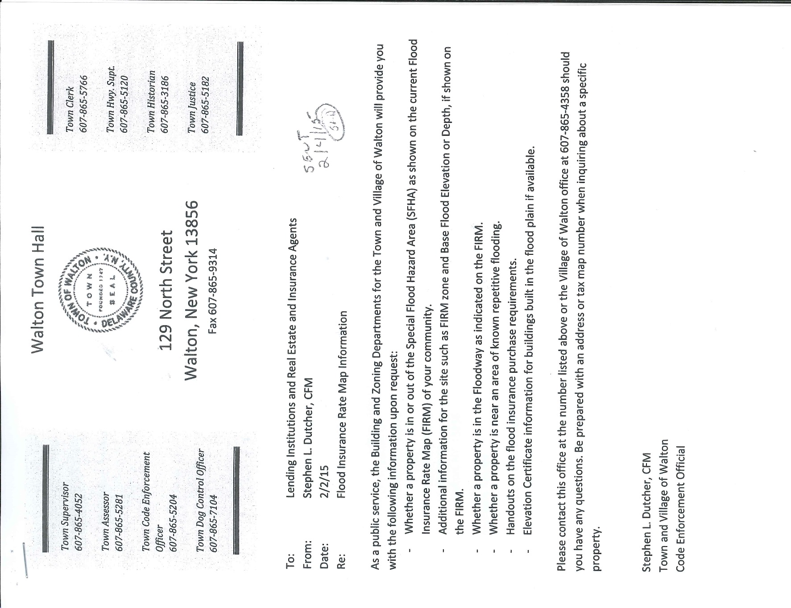

# Activity 330 Outreach

Special Flood Hazard Area residents and businesses that are located within the SFHA zones should be aware of the flood hazards and methods that can be used to protect themselves and property, but most importantly the availability of flood insurance. The Town and Village of Walton have recently updated the Flood Insurance maps and there is a need to educate residents that were not in flood zones and are now mapped in flood areas about the flood insurance and the options on how to reduce their insurance through the community rating system. To reach the general public through direct mailings, articles in the local newspaper and information on municipal websites are ways to continue to share information. Updating the community on the progress of flood reduction projects and programs through outreach events such as a booth at the Delaware County Fair held in August or other public events, radio interviews, and press releases are also potential ways to reach out to the general public. The PPI committee selected four messages to be disseminated to targeted audiences for each of the six priority topics for the CRS topics listed below:

1. Know your flood hazard
2. Insure your property for your flood hazard
3. Protect people from the hazard
4. Protect your property from the hazard
5. Build responsibly
6. Protect natural floodplain functions

Additional Topics:

1. Flood Warning – It is important for the public to know how they will be notified in an emergency and where to get information

First time homebuyers should be aware of the risks when they are purchasing a home in an area that is located in a SFHA. Programs through the Delaware County Opportunities offer assistance in applying for grant towards down payment, closing costs and repairs necessary to close on a house in the Village or Town of Walton. This program educates potential buyers through informational pamphlets and brochures and classes that include presentations and counseling.

Messages:

1. Know the flood hazards
   1. Check with your real estate agent prior to purchase
   2. Consideration of flooding by checking flood maps
   3. Review the property condition disclosure statement
   4. Is there an elevation certificate
2. Protect your home
   1. Elevate the utilities or structures
   2. Anchor and elevate fuel and propane tanks
   3. When making repairs use flood damage resistant materials in areas below the Base Flood Elevation
   4. Substantial damage/improvement
3. Resources
   1. Technical bulletins and other FEMA documents from the FEMA website
   2. Flood Maps
      1. Village of Walton Municipal Office, Town of Walton Municipal Office, William Ogden Free Library, [www.msc.fema.gov/portal](http://www.msc.fema.gov/portal)

Real estate brokers and agents, lending institutions and insurance companies are important avenues to get flood hazard information to their clients. The PPI committee has been working hard to be able to reach out to these groups and develop reporting procedures for documentation of information given to clients. The PPI committee has developed a training program for Real Estate agents and is working towards the program being a credited training to encourage participation.

Messages:

1. Understanding flood insurance
   1. Learn how to reduce flood insurance in the community
      1. Community Rating System (CRS)
   2. Learn how to use flood maps
   3. Learn how real estate agents can communicate flood risk to clients

Renters should be aware of the risks when they are renting a home in an area that is located in a SFHA. Renters should be encouraged to obtain floodplain insurance

Messages:

1. Understanding flood insurance
   1. Learn how to insure your processions
   2. Learn how to use flood maps
2. Know the flood hazards
   1. Learn about your flood risk
   2. Consideration of flooding by checking flood maps
3. Protect people from flood hazard
4. Know the community’s emergency plans
5. Prepare your own family plan
6. Do not drive or walk in flood waters (Turn around Don’t Drown)

Floodplain reclamation and streambank projects are being constructed throughout the Town and Village of Walton and it is important to inform the public about the importance of floodplain protection. The PPI committee is committed to hosting events, public presentations and providing outreach information through local media.

Messages:

1. Understanding floodplain functions
   1. Creation of floodplains may remove structures from the 100-year flood maps areas and getting properties out of harm’s way while reducing flood insurance.

The Walton Flood Commission (PPI committee) has completed a number of public presentations throughout the development of the Local Flood Analysis study to all floodplain residents and business. The committee will continue to provide training opportunities to the community through workshops, stream walkovers, press releases, brochures, direct mailings, YouTube videos of presentation and trainings, website information, and Emergency Post-Flood Stream Intervention training to contractor and municipal highway staff to inform the public the importance of protecting life and property, buy flood insurance, and protecting natural floodplain functions.

**Table 5**

**Outreach Projects**

|  |  |  |  |  |  |
| --- | --- | --- | --- | --- | --- |
| **Target Audience** | **Message** | **Outcome** | **Projects** | **Assignment** | **Schedule** |
| **SFHA Residents** | All residents in flood prone areas should have flood insurance  Topics 1,2,3,4 | Increase in NFIP policies | Outreach Letter | Floodplain Manager | Start as soon as possible |
| How to protect or reduce impacts to your property from flooding hazards  Topics 1,2,3,4,5 | Increase in permits for retrofitting projects | Booth at spring home expo | Floodplain Manager | Spring 2016 |
| Retrofitting property to reduce flood insurance  Topics 1,2,3,4,5,6 | Educated Contractors | Seminar to review flood regulations and retrofitting projects | Floodplain Manager | October 21, 2015 |
| Protect people through Flood Warning system  Topic 7 | Decrease number of rescues | Letter | Floodplain Manager | Annual |
| Post-flood programs and projects  Topic 6 | Flood reduction activities/outreach post-flood events | Educational event with vendors and displays | Flood Commission, technical advisors | July 23, 2016 |
| **First Time Homebuyers** | Know your Flood Hazard when buying a home  Topics 1,2,3,4 | Educated Homebuyers | Seminar to review flood related topics when buying a new home | Floodplain Manager | January 20, 2016 |
| Know Your Flood Hazard to educate clients on what to look for when buying a home  Topics 1,2,3,4,5,6 | Educated First Time Homebuyer Grant Management Team | Seminar to review flood related topics when buying a new home | Floodplain Manager | November 2, 2015 |
| **Residents in LFA study area** | Flood awareness and local community projects to reduce flood impacts  Topics 1,2,3,4,5,6 | Increase in public participation in LFA process | Letter  Door to door outreach | Flood Commission | As prescribed by the LFA process |
| **Realtors** | Flood Insurance and your Client’s Home  Topics 1,2,3,4,5 | Educate Realtors and develop reporting documents | Seminar to review flood related topics when selling a new home | Floodplain Manager | May 24, 2016  Fall 2016 |
| **Recreational Enthusiast** | Flood Insurance, Flood awareness and local community projects to reduce flood impacts  Topics 1,2,3,4,5,6,7 | Education on NFIP, local projects, Flood Educational opportunities | Informational Kiosk at Ice House Boat Launch | Flood Commission, technical advisors | Start as soon as possible and review to update information annually. |

# Activity 340 Hazard Disclosure

With the increasing concerns of flood hazard the public’s awareness to investigate property prior to purchasing has been incorporated into the disclosure of property sales as part of the New York Real Property Article 14-462 Property Condition Disclosure Statement. The property condition disclosure act requires the seller of residential real property to cause this disclosure statement or a copy thereof to be delivered to a buyer or buyer’s agent prior to the signing by the buyer of a binding contract of sale. This disclosure asks the seller if the property is located in a designated floodplain or wetland and whether or not there is any flooding, drainage or grading problems that resulted in standing water on any portion of the property. The PPI committee recommends expanding this documentation to include real estate agents brochures for flooding hazards or provide other material to notify buyers of hazards specific to the property of sale and to work with realtor agents to develop a reporting system to document all discussions with clients. The Code Enforcement Officer with guidance from the PPI committee will continue to provide real estate agents with training and technical assistance on topics that will include how to read a floodplain map, how to determine if a home is located in the SFHA and the importance of flood insurance to assist in identifying hazards in order to provide the best disclosure information to the clients.

# Activity 350 Flood Protection Information

The Village and Town of Walton shall make available and keep up to date with flood information on their municipal websites: <http://villageofwalton.com/walton/content/floodinfo.php> or <http://townofwalton.org/flood-plain-management/>. The information that is available on the websites:

1. Contact information for the local floodplain manager who will provide you with information on the flood hazards and flood protection measures as well as any other questions that are flood related matters.
2. Document links to the 2007 Code Administration and enforcement of the NYS Uniform Fire Prevention and Building Code Law, 2012 Flood Law, Floodplain Development Applications and Elevation Certificate procedures.
3. Flood maps for the current June 2016 maps and the September 1988 and June 2012 historic maps
4. Real Time Stream Data Links for the USGS Gage 01423000 West Branch Delaware River at Walton, NY so users can see current water levels and flood height predictions can be found on the National Weather Service’s Advanced Hydrologic Prediction Service <http://water.weather.gov/ahps2/hydrograph.php?wfo=bgm&gage=waln6>
5. Reference website links for preparation, recovery and insurance information.
6. Flood mitigation projects that have been completed within the Village and Town of Walton and copies of the Local Flood Analysis plans.

The information available on the website will be maintained by the floodplain manager or other designated municipal official to provide updates annually or continuously when important information becomes available.

The Village and Town of Walton’s floodplain manager shall review annually and maintain materials at the William B. Ogden Free Library to include the following documents:

* Above the flood: elevating your flood prone house
* Answers to questions about the National Flood Insurance Program
* Elevated residential structures
* Protecting building utilities from flood damage: principles and practices for the design and construction of flood resistant building utility systems
* Protecting manufactured homes from floods and other hazards: a multi-hazard foundation and installation guide
* Reducing damage from localized flooding: a guide for communities
* State of New York comprehensive annual financial report for the fiscal year ended March 31
* State of New York comprehensive annual financial report for the fiscal year ending March 31, financial condition report
* Delaware County All-Hazard Mitigation Plan Volumes 1 and 2
* Flood Insurance Study for the Village, Town of Walton, and Delaware County
* Flood Insurance Maps for the Town and Village of Walton
* Flood maps for Delaware County

# Activity 360 Flood Protection Assistance

The Village and Town of Walton provide flood protection assistance through the floodplain manager that includes property protection advice and advice after a site visit. These types of assistance to the floodplain residents and business owners can be found on the municipal websites or by contacting the municipal office. The PPI committee request that all property owners in the SFHA be sent a direct mailing annually advertising the service and that this service be advertised annually at the Delaware County fair booth and any workshop or public event sponsored by the Walton Flood Commission. The floodplain manager with assistance from technical staff shall provide a one-on-one advice about property protection upon request. The PPI committee shall promote this service as part of the outreach efforts outlined in Table 6 – Outreach Projects. All site visits and public assistance shall be documented. The Walton Flood Commission encourages any training to be available to assist the floodplain manager and technical staff to attend in order to be up-to-date on all flood related topics.

# Activity 370 Flood Insurance Promotion

Flood Insurance Coverage Assessment (FIA) – This process assesses the community’s current level of flood insurance coverage to identify where improvement is needed. The first step is to determine the flood problem areas in the SFHA and areas outside the SFHA. The PPI committee has reviewed the NFIP policy information including the Town and Village of Walton’s current level of coverage. The committee’s analysis and identification of short comings are listed in detail in the section on National Flood Insurance Program.

# Activity 420 Open Space Preservation (NFOS5)

The Walton Flood Commission is dedicated to keeping the community sustainable and flood resilient. In selecting projects the commission’s priority is to first reclaim and protect as much floodplain as possible to reduce flood elevations with minimal need to move homes and businesses. Where homes and businesses are impacted the priority is to relocate them within their respective municipality in an effort to keep the community whole. It is important for the community to be a part of the process and recognize that all projects are volunteer and locally lead. These potential floodplain projects can be found in the West Branch Local Flood Analysis plan and in the draft plans of the East Brook, West Brook, Third Brook tributaries. The map below shows the existing open space within the Village of Walton. The Walton Flood Commission is in the process of designing a floodplain reclamation project to be built in 2017 located at Site 11 on map 3 below.

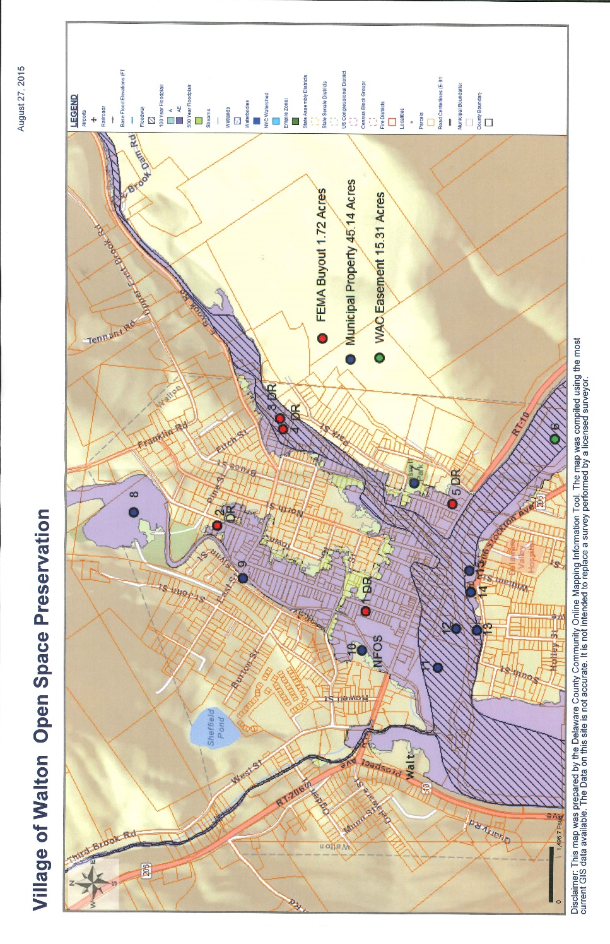

**Map 3**

The Town and Village of Walton have adopted resolutions for three municipal properties within the village limits to preserve open space in perpetuity. These three properties are located within the SFHA as depicted in the map 4 below and are identified in the Town Resolution Number 84 as Tax Parcels ID #273.7-7-13 and 273.7—7-27.21 and Village Resolution Number 2015-9-1 as Tax Parcel ID #273.7-7-27.1. Both resolutions state that the parcels will be graded to store and facilitate the flow of floodwater back towards the river channel and that the municipalities will maintain the parcel as open space for purposes of community enjoyment and flood hazard mitigations. The Town of Walton has received funding from NY Senator John Bonacic to purchase and remove an existing building on Tax Parcel ID #273.7-7-13 as part of a flood mitigation project to reduce water and create a green space. The green space is part of a larger project to restore floodplain along Water Street on Tax Parcel ID #273.7-727.1 that was historically used as a place to store fill. A Water Resource Development Act (WRDA) grant was received through the US Army Corps of Engineer to construct a floodplain enhancement project that will treat 2.8 acres of stormwater runoff from building roof tops and parking lots on the 13.2 acres with a natural species vegetated floodplain and riparian buffer. The project removed excess fill to the natural floodplain surface allowing the water to drain from Delaware Street through a filter area and riparian buffer. The Local Flood Analysis plans for the West Branch Delaware River and the three tributaries identify other floodplain reclamation projects that can be constructed to reduce the flood impacts within the SFHA. Walton Flood Commission has reached out to the individual landowners and conducted stream walkover where the floodplain reclamation projects have been identified in the LFA plan. PPI committee seeks to enhance the public’s awareness through presentations, brochures and newspaper press releases about the floodplain reclamation projects within the community and open space preservation as each of the projects moves forward. This awareness will provide educational material on the project site’s natural functions, such as the purpose and goals of the project and the impacts to the community’s reduction of flood elevations. A brochure will be developed by the PPI committee to be placed in a box on the informational kiosk sign as part of the Water Street floodplain reclamation project.

**Map 4**

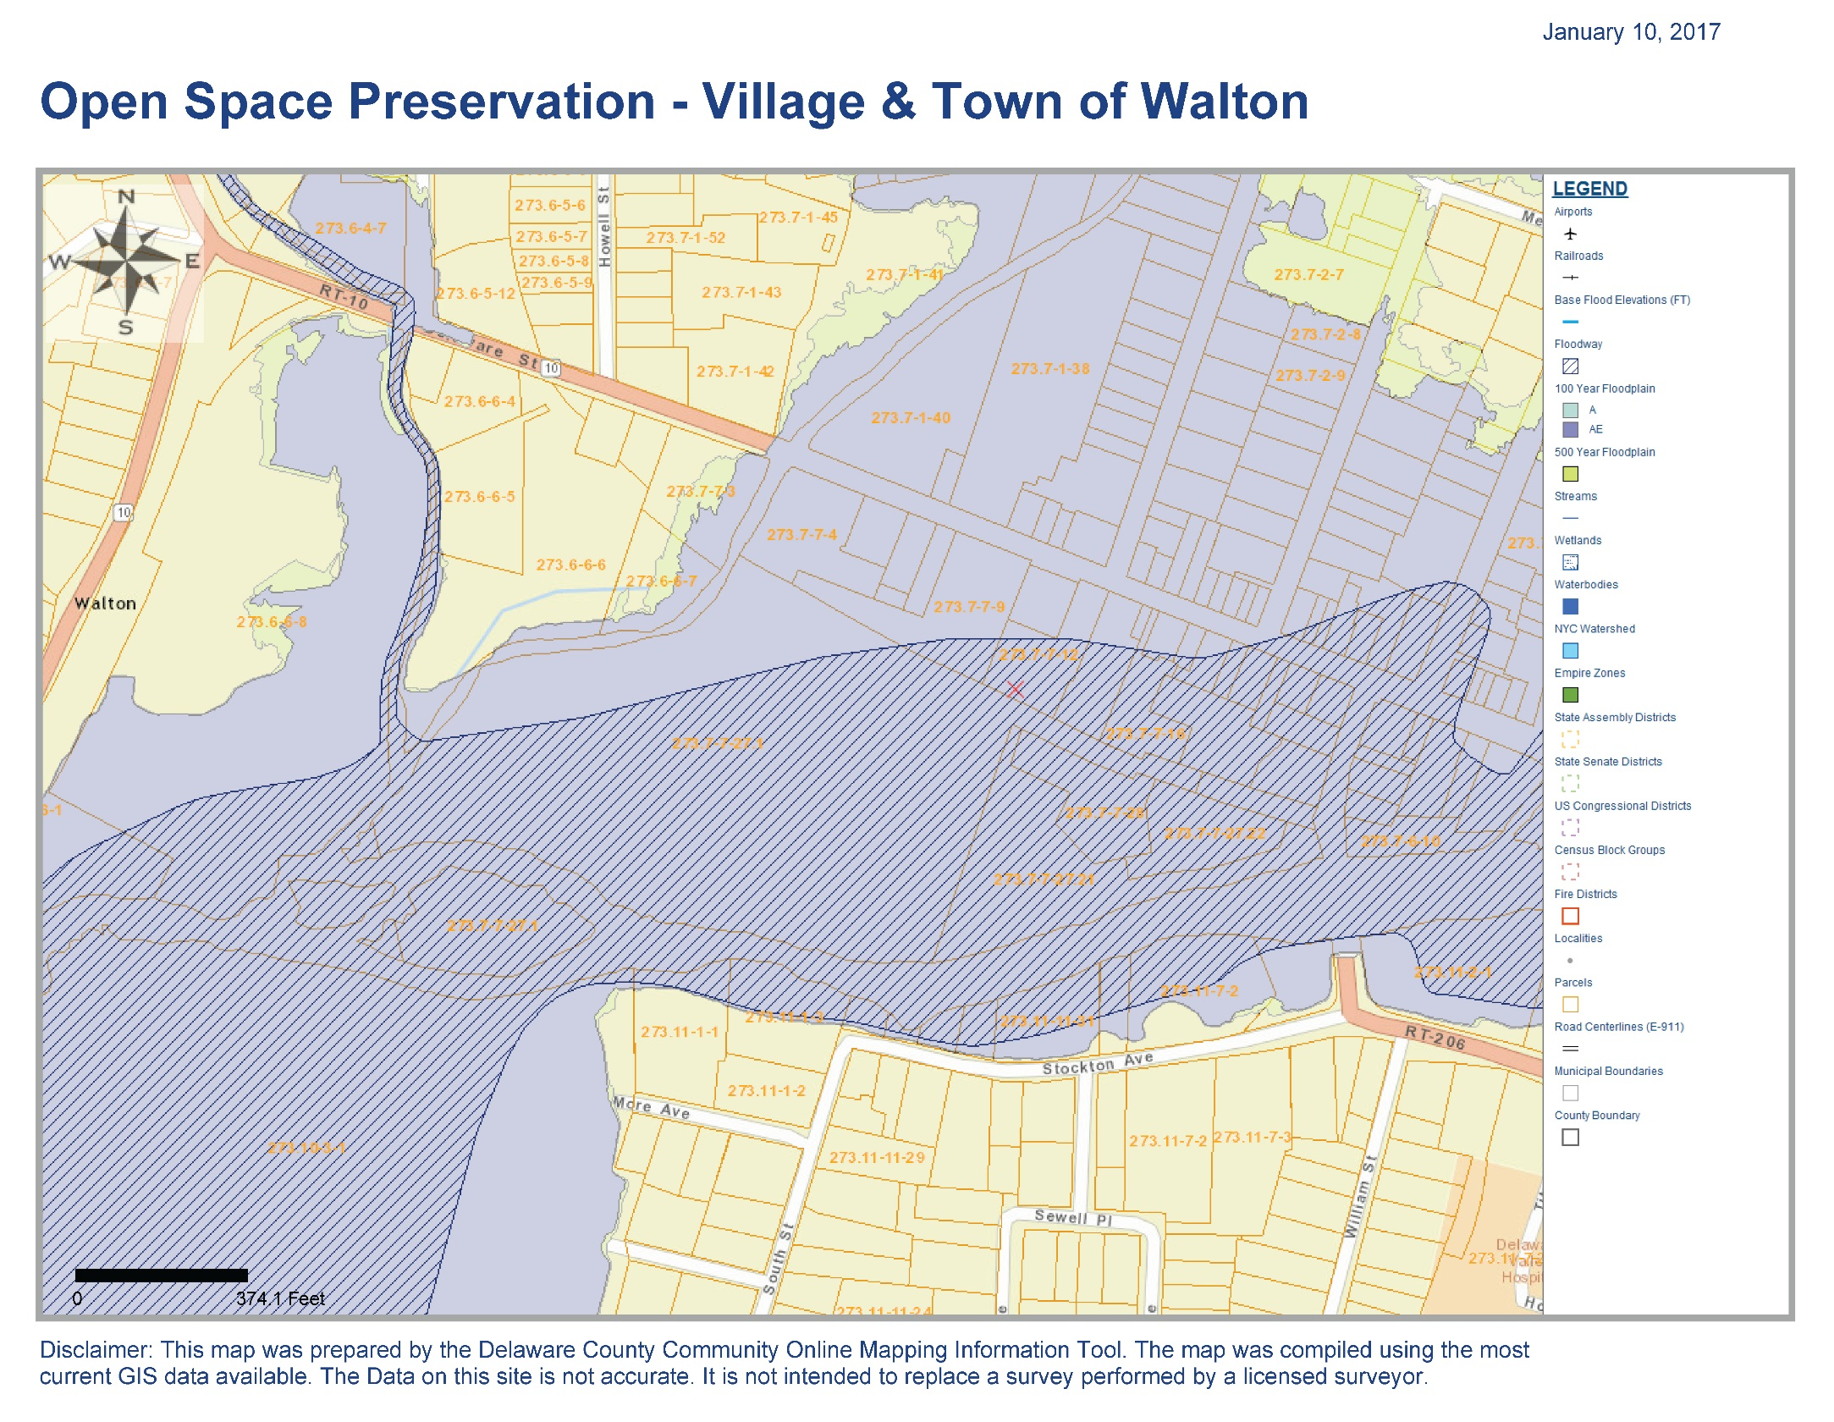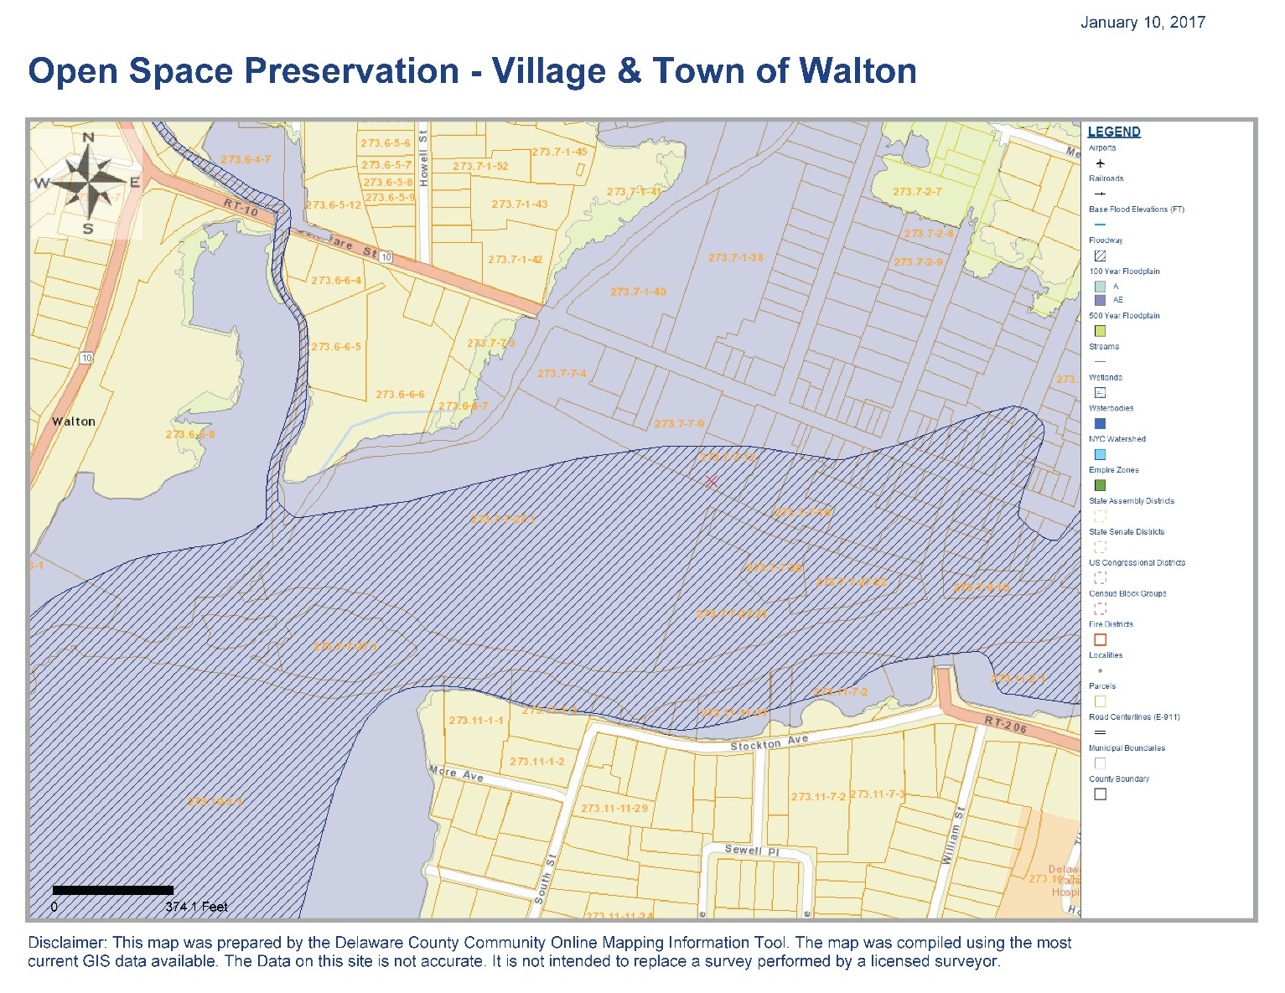

**273.7-7-27.1**

**273.7-7-21**

**273.7-7-13**

# Activity 610 Flood Warning and Response

The Delaware County Emergency Alert System Plan has been developed for the entire county to utilize to alert the citizens of the affected areas of Delaware County of a natural or technical disaster. The objective of the plan is to document the steps and procedures for local officials to take for the proper notifications to the citizens of impending emergency. Information and warnings to the public that a threatening condition is imminent can be accomplished through the use of the following resources:

1. Disseminating emergency information directly to the public through local broadcasting media.
2. NOAA Weather Radio will provide continuous 24-hour radio broadcasts of the latest weather information including sever weather warnings directly from the Weather Service office in Binghamton.
3. Reverse 911 will be utilize to call target affected areas with an emergency message.
4. Emergency service vehicles with siren and public address capabilities. Many police and fire vehicles in the County are equipped with siren and public address capabilities.
5. Door-to-door public warning can be accomplished in some situations by the individual alerting of each residence/business in a particular area. This can be undertaken by any designated group such as auxiliary police, regular police, fire police, and regular firefighters, visiting each dwelling in the affected area and relating the emergency information to the building occupants.

The Walton Flood Commission (PPI committee) should work with the Delaware County Emergency Service and the Walton Fire Department to develop flood warning system educational information that identifies flood hazard warning signals, evacuation and flood safety and develop a way to disseminate flood warning information year-round. Real Time Stream data is link on the Village and Town of Walton’s website as well as links for floodsmart.gov and redcross.org.

# Annual Evaluation

The PPI committee shall continue to meet monthly at the Walton Flood Commission meetings. At the meetings it will be determined if there are any educational opportunities as community events are announced throughout the year. The PPI document will be evaluated at least once a year to determine if any revisions are necessary. The evaluation and documentation shall cover the following:

* The target audiences, the messages, and the desired outcomes
  + Changes in target audiences
  + Additional messages or topics that are flood related
* The projects in the PPI used to convey the messages
  + Which projects were implemented
  + Addition or omission of projects as the communities move forward with flood projects
  + Why some projects were not implemented (if any)
* What progress was made toward the desired outcomes
* What should be changed (including what messages, outcomes, and projects should be revised or dropped, and what new ones should be initiated).
  + The enhancement of recommendations to convey a better flood awareness messages to key stakeholders.

The floodplain manager shall be responsible for the update and evaluation of this PPI document which will be included as part of the Town’s and Village’s CRS recertification. The floodplain manager shall provide the documentation of the review and evaluation of the PPI documents annually. This shall be in a form that shows the outreach and education efforts that were completed with copies of the sign in sheet, agenda and any other reference material.

# Adoption

On _______ , the Village of Walton held a public hearing and formally adopted the Program for Public Information, as recommended by the Walton Flood Commission (PPI committee).

On _______ , the Town of Walton held a public hearing and formally adopted the Program for Public Information, as recommended by the Walton Flood Commission (PPI committee).